Nalongsone Danddank Student ID : 14958950 StarID: jf3893pd

Email: [nalongsone.danddank@my.metrostate.edu](mailto:nalongsone.danddank@my.metrostate.edu)\

**ICS 432 - 01 — Distributed and Cloud Computing Fall 2021**

**Lab #8 :** Using Cloud Relational Database System (RDS)

Exercise 1: Relational Databases on AWS

**Lab report screen-shot #1:**

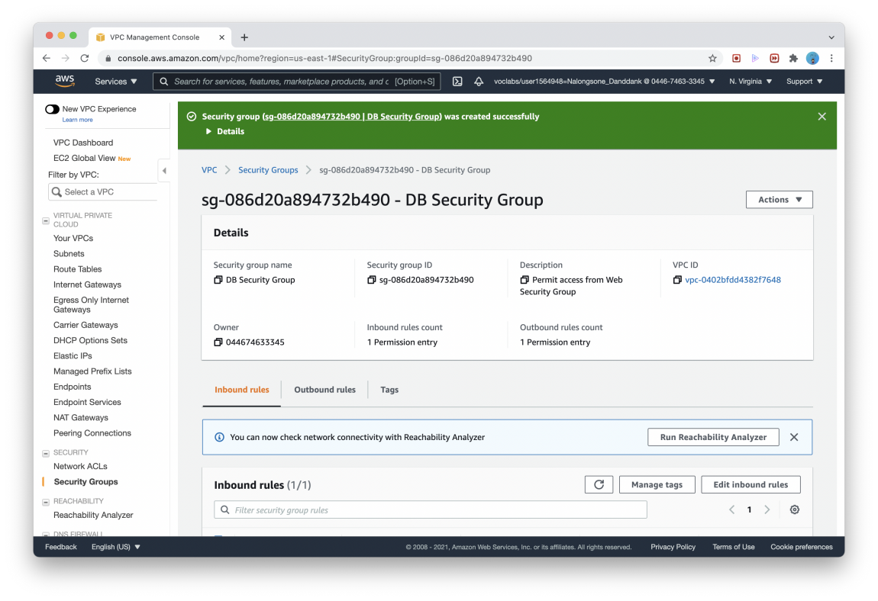

**Lab report screen-shot #2:** lab-db.c5iulndppurs.us-east-1.rds.amazonaws.com

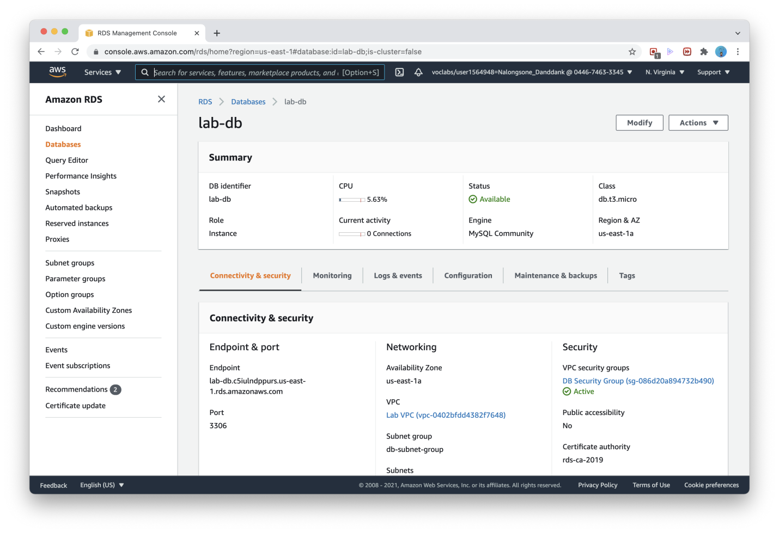

**Lab report screen-shot #3:**

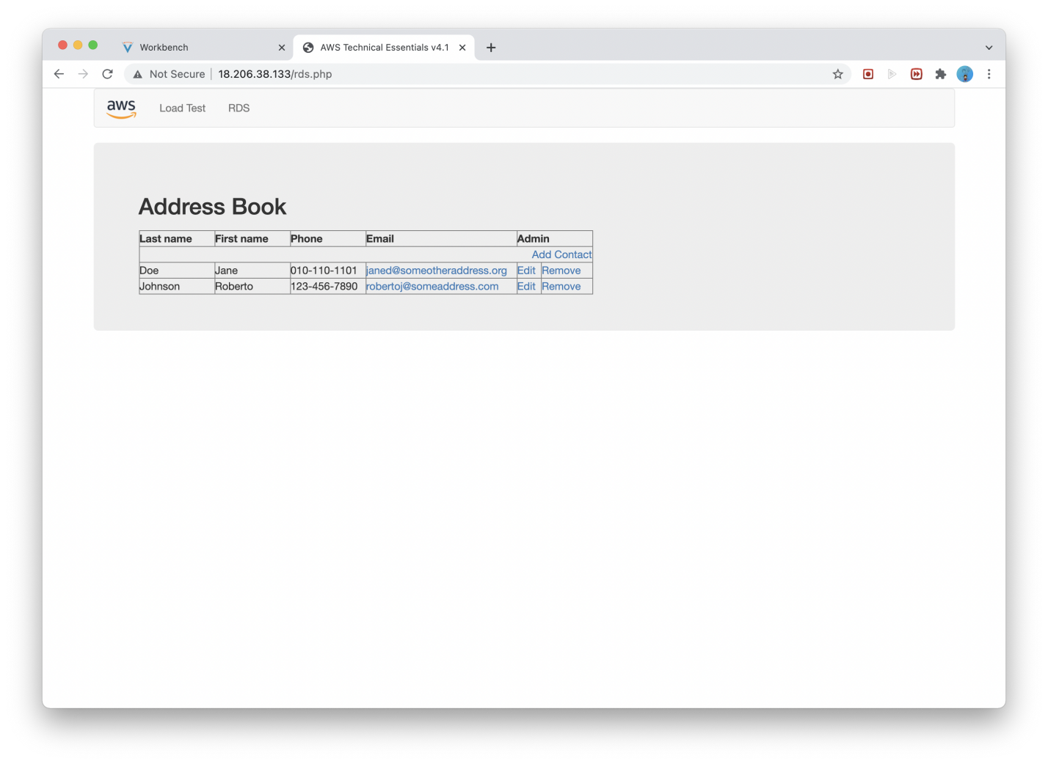

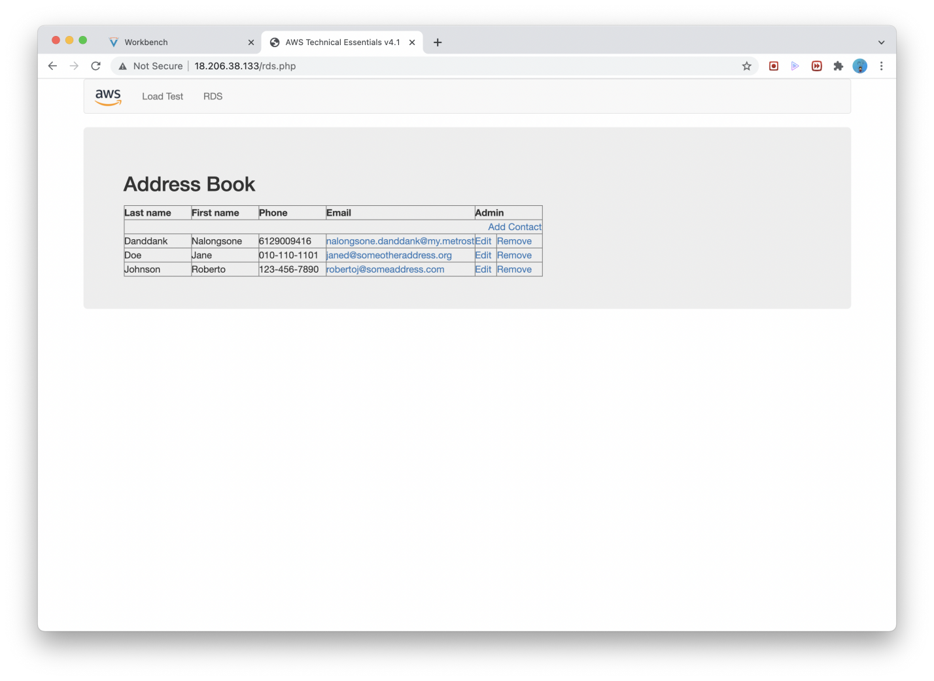

**Lab report screen-shot #4:**

danddank-database.c8wffoskckyb.us-east-1.rds.amazonaws.com

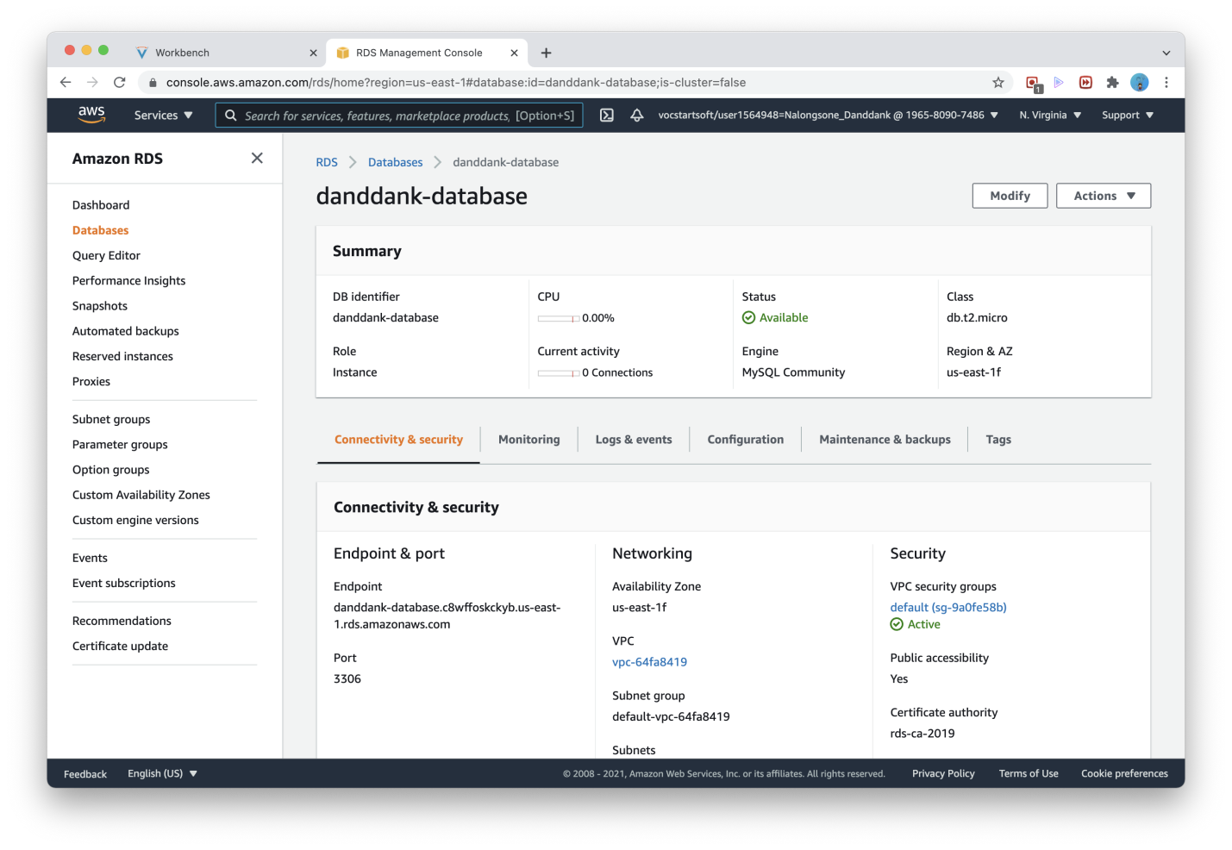

**Lab report screen-shot #5:**

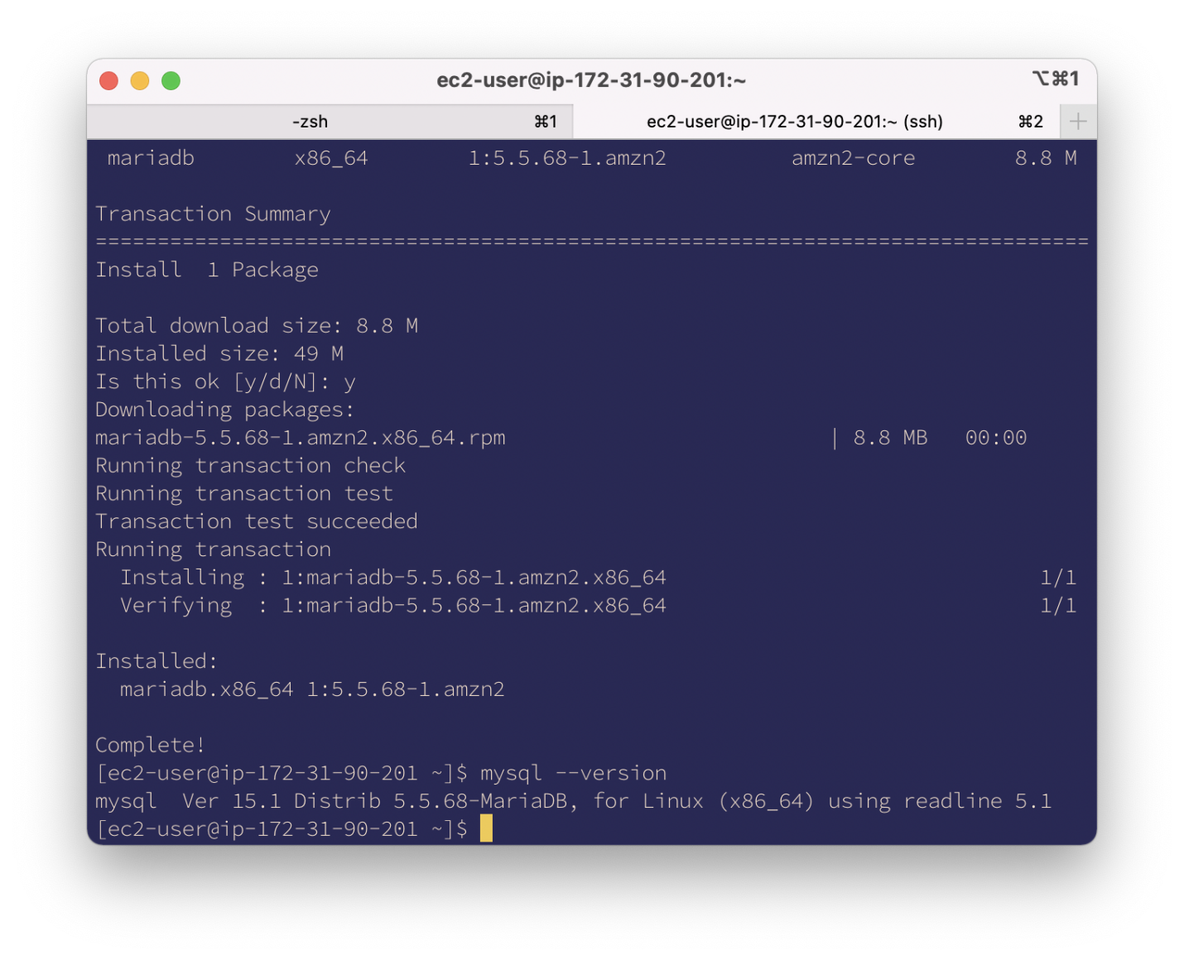

**Lab report screen-shot #6:**

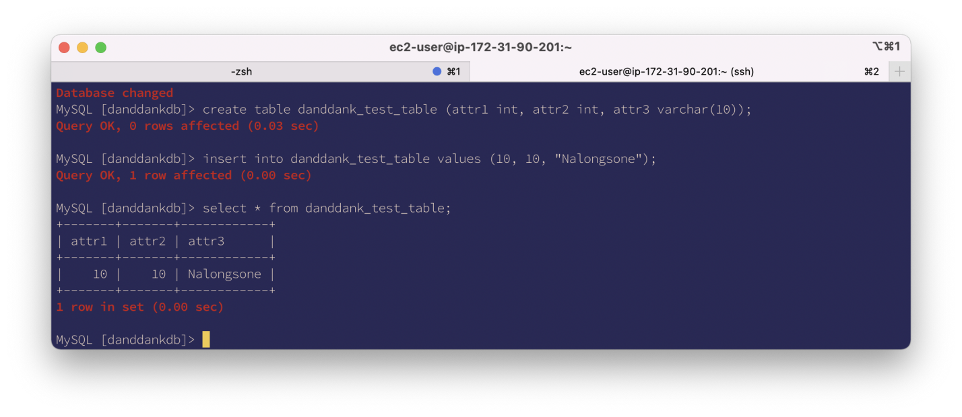

**Lab report screen-shot #7:**

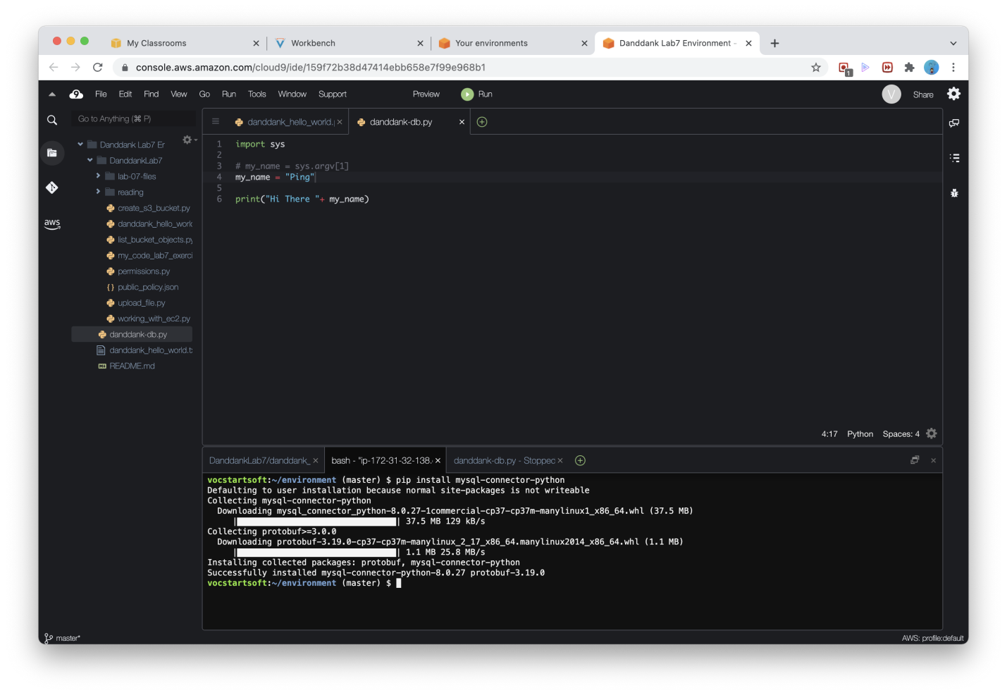

**Lab report screen-shot #8:**

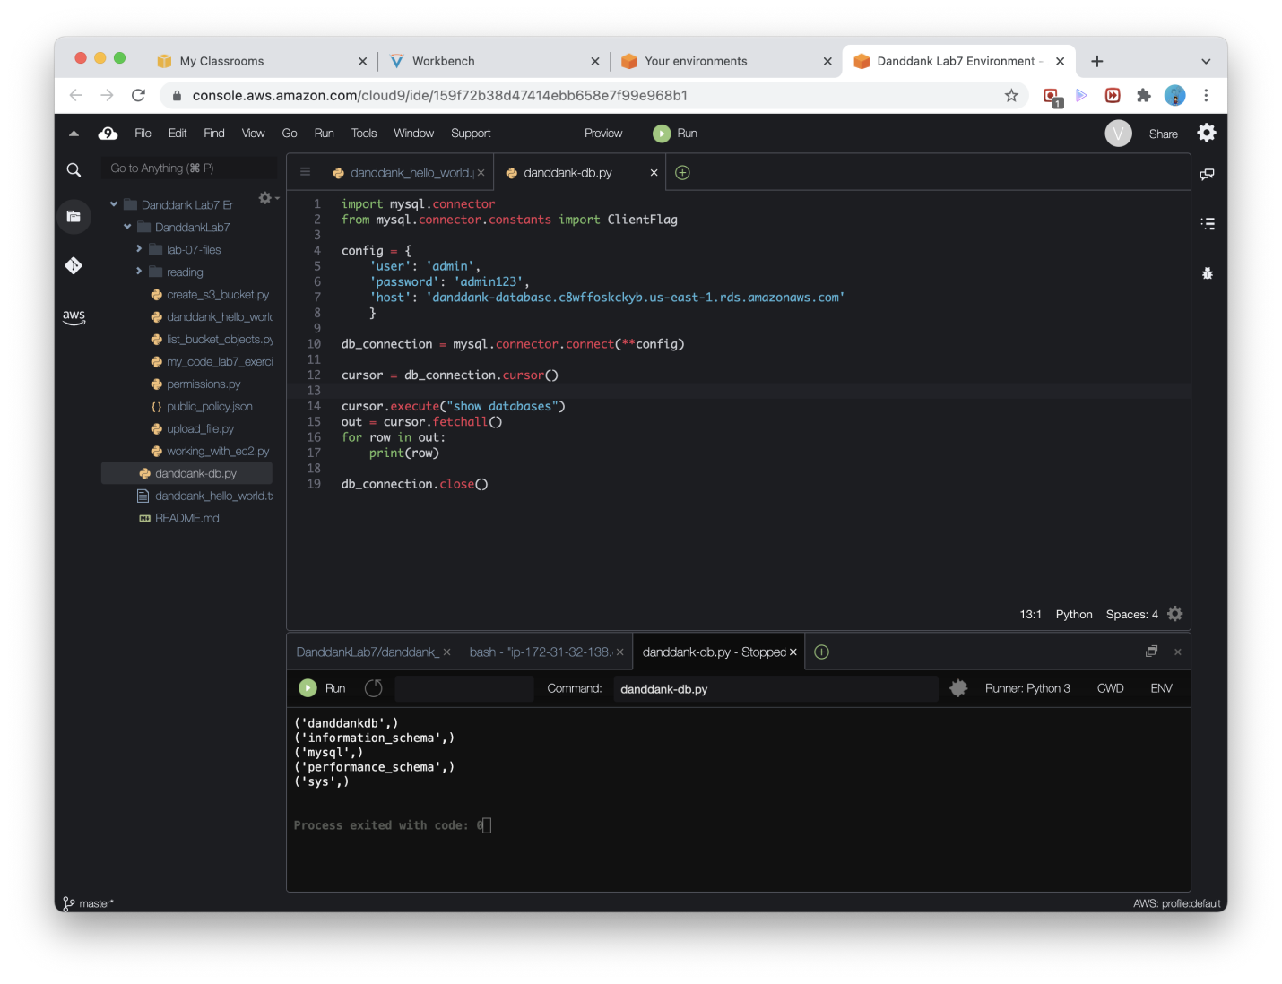

**Lab report screen-shot #9:**

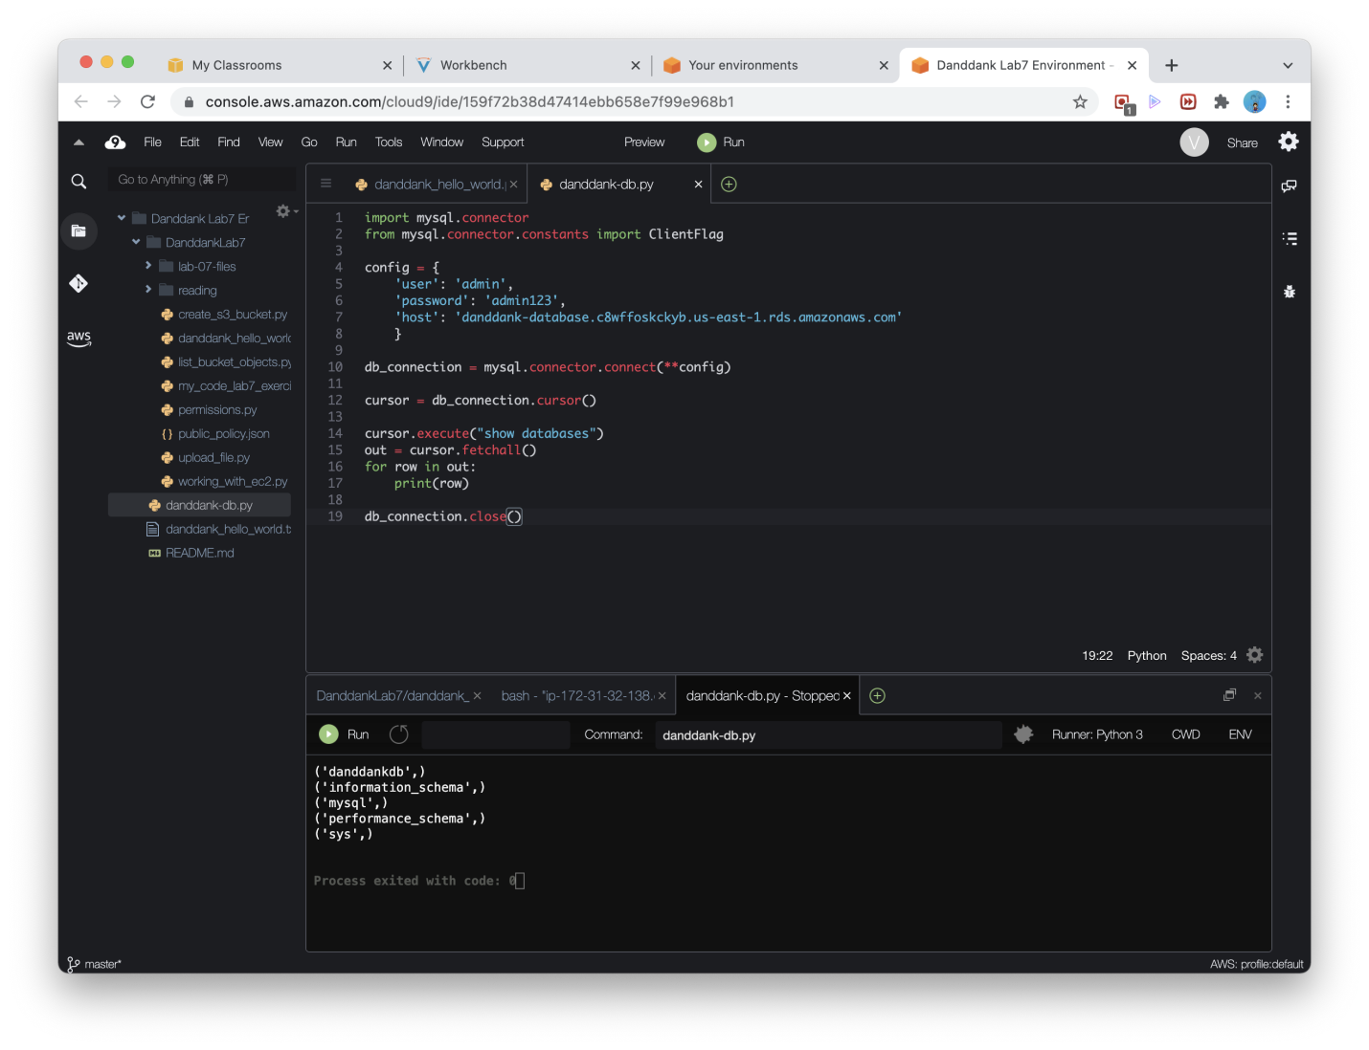

**Lab report screen-shot #10:**

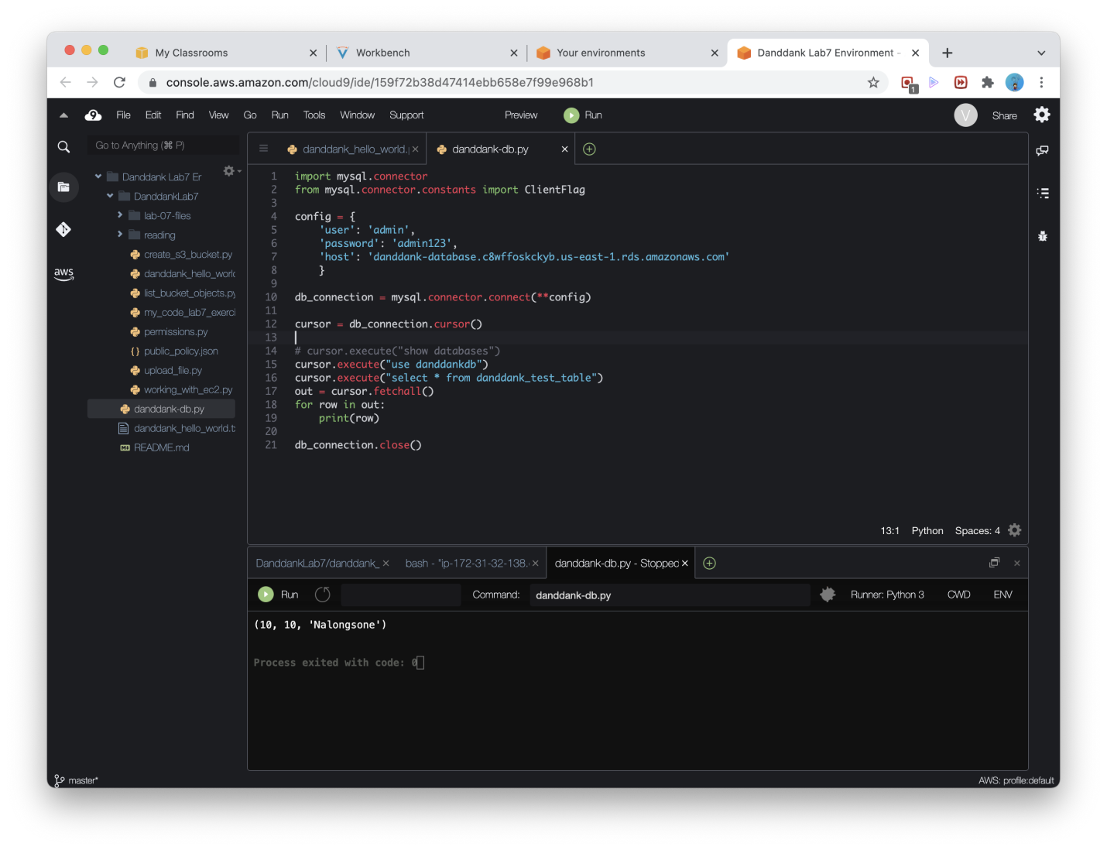

**Lab report screen-shot #11:**

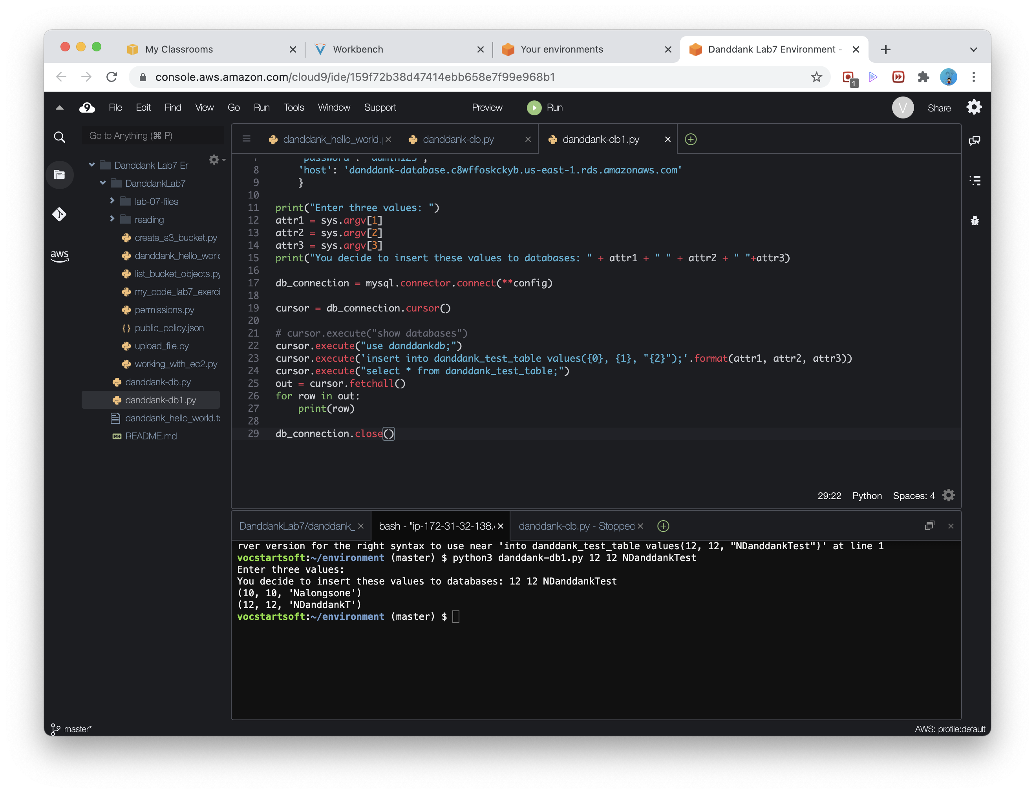

**Lab report screen-shot #12:**

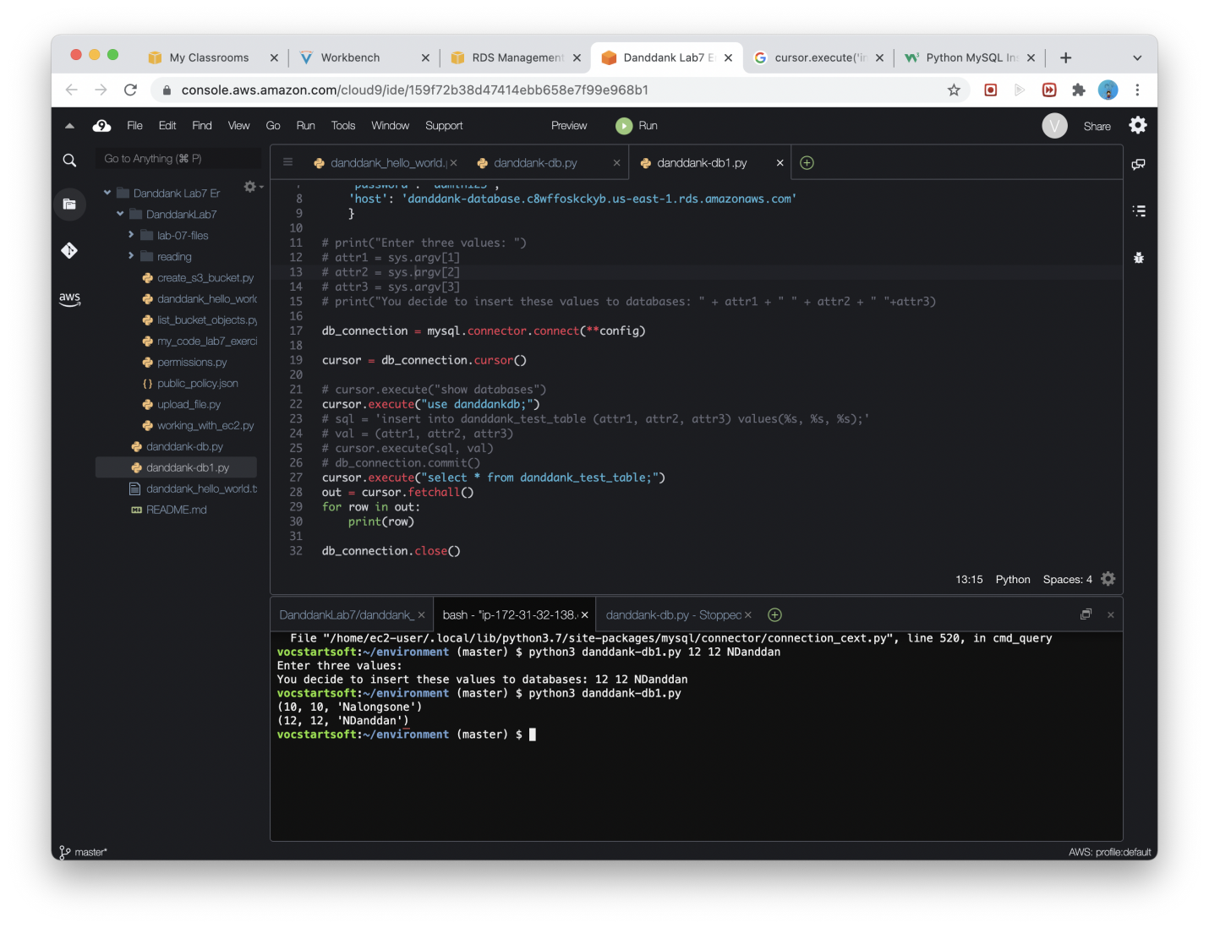

**Lab report screen-shot #13:**

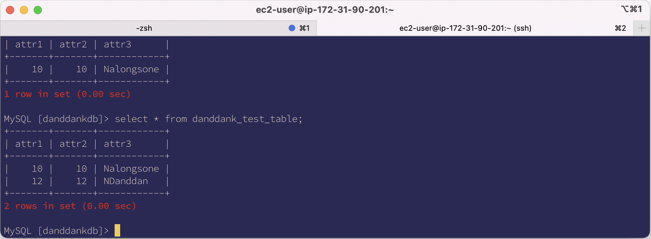

Exercise 2: Relational Databases on GCP

**Lab report screen-shot #14: 146.148.93.171**

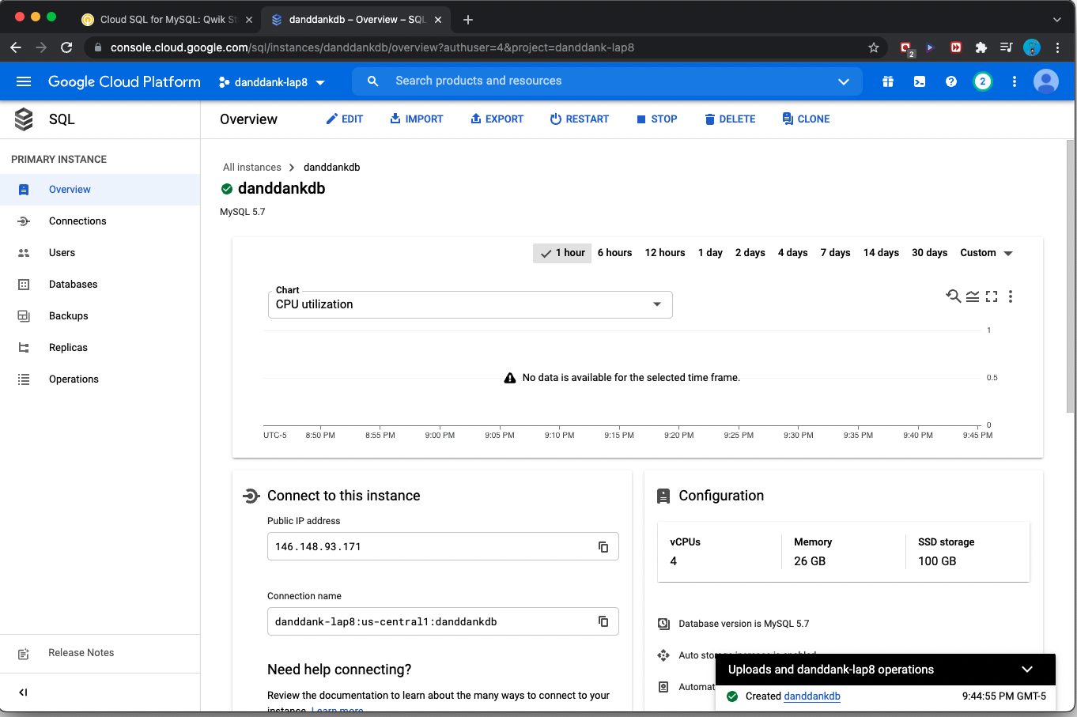

**Lab report screen-shot #15:**

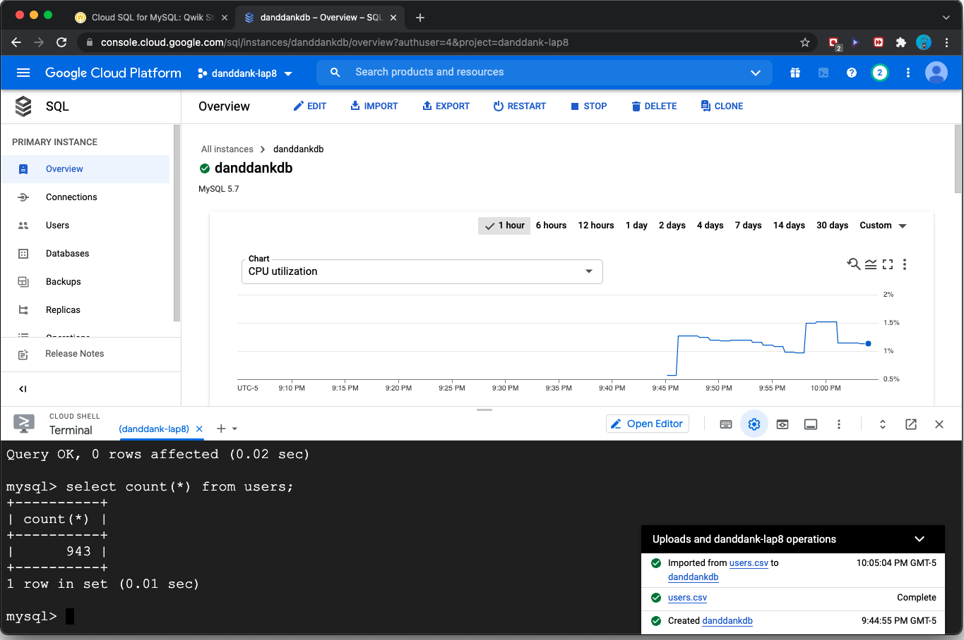

**Lab report screen-shot #16:**

**mysql -uroot -p -h 146.148.93.171 --ssl-ca=server-ca.pem --ssl-cert=client-cert.pem --ssl-key=client-key.pem**

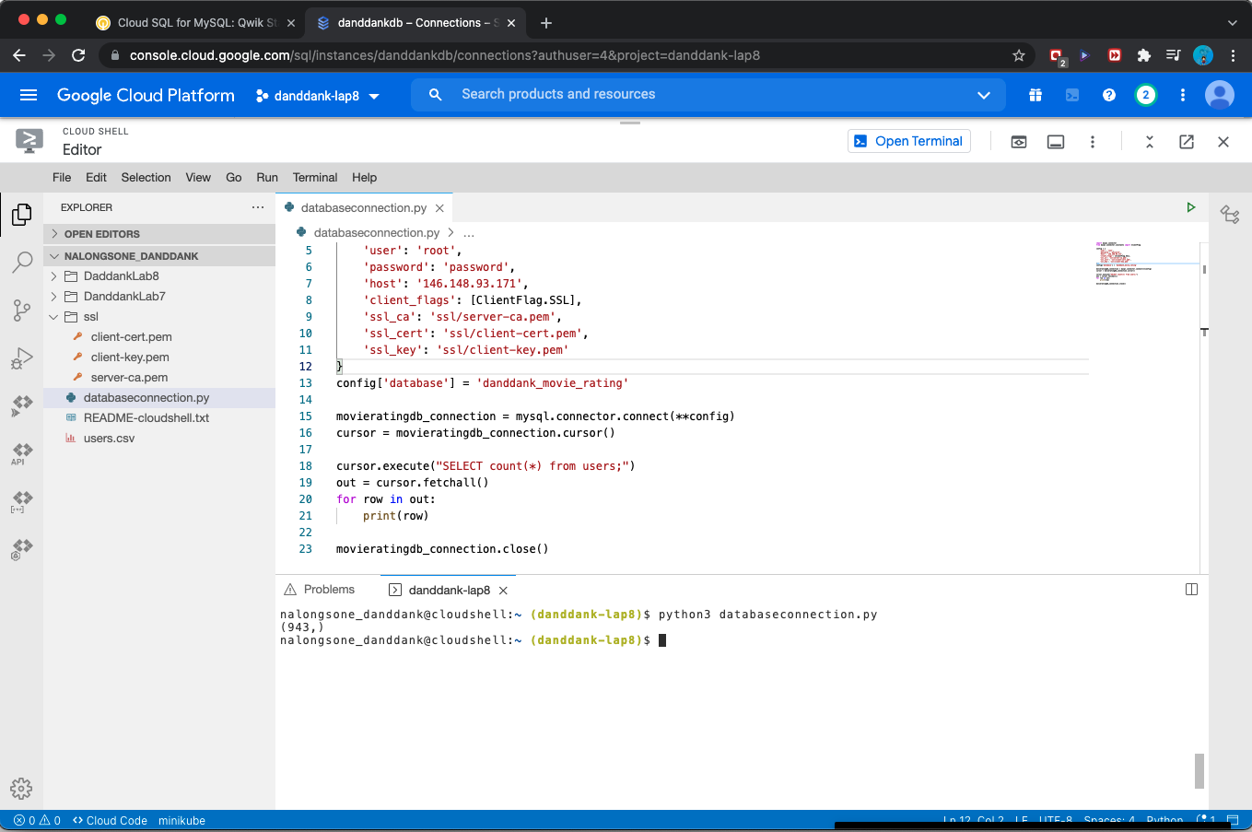

**Lab report screen-shot #17:**

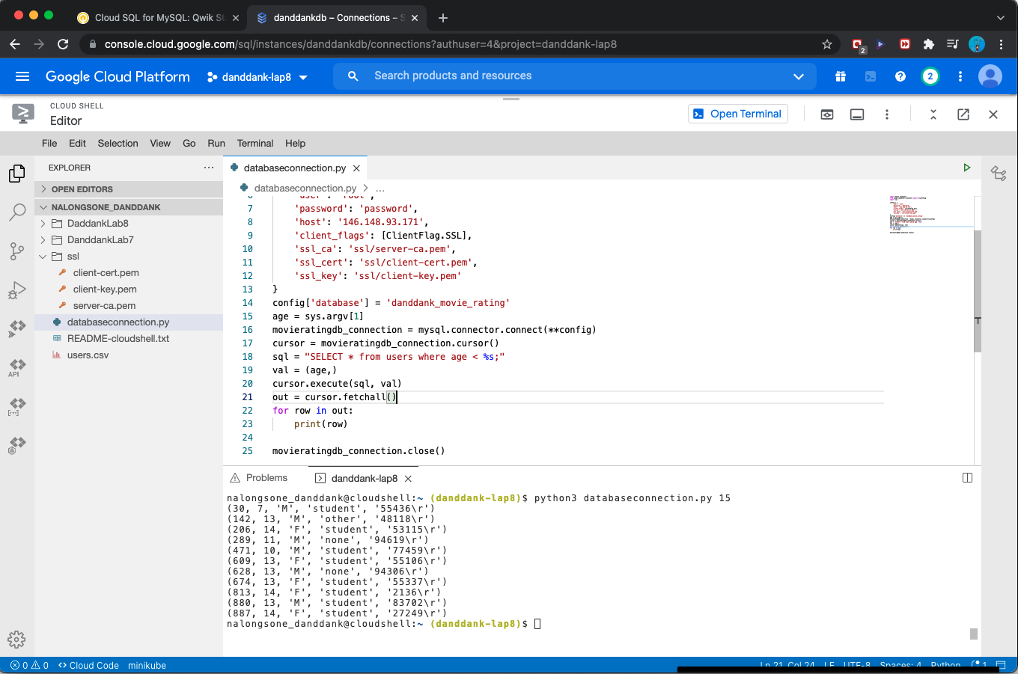

**Lab report screen-shot #18:**

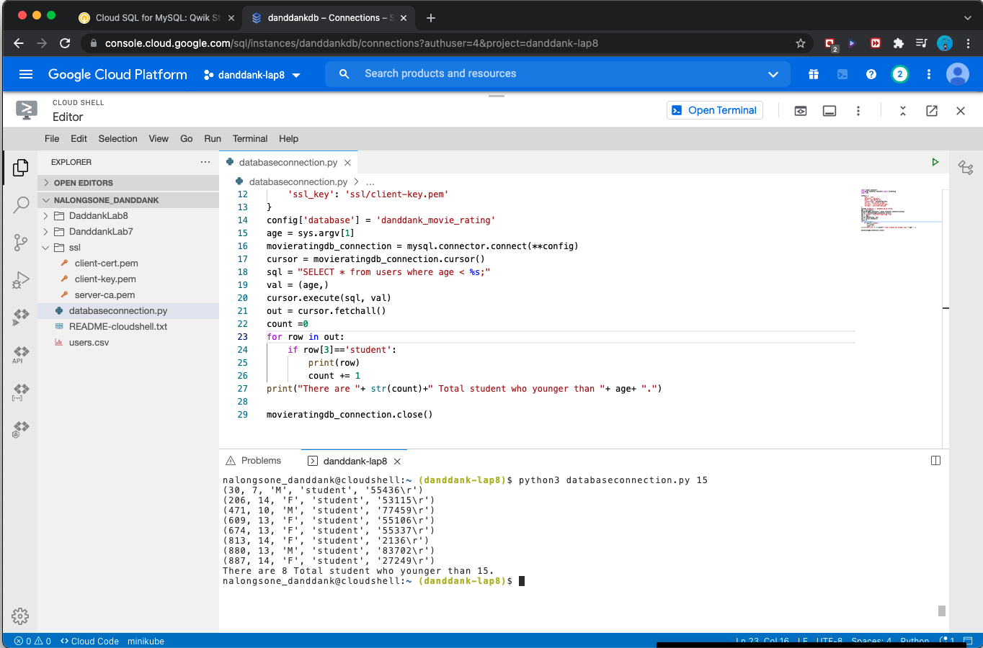

**Lab report screen-shot #19:**

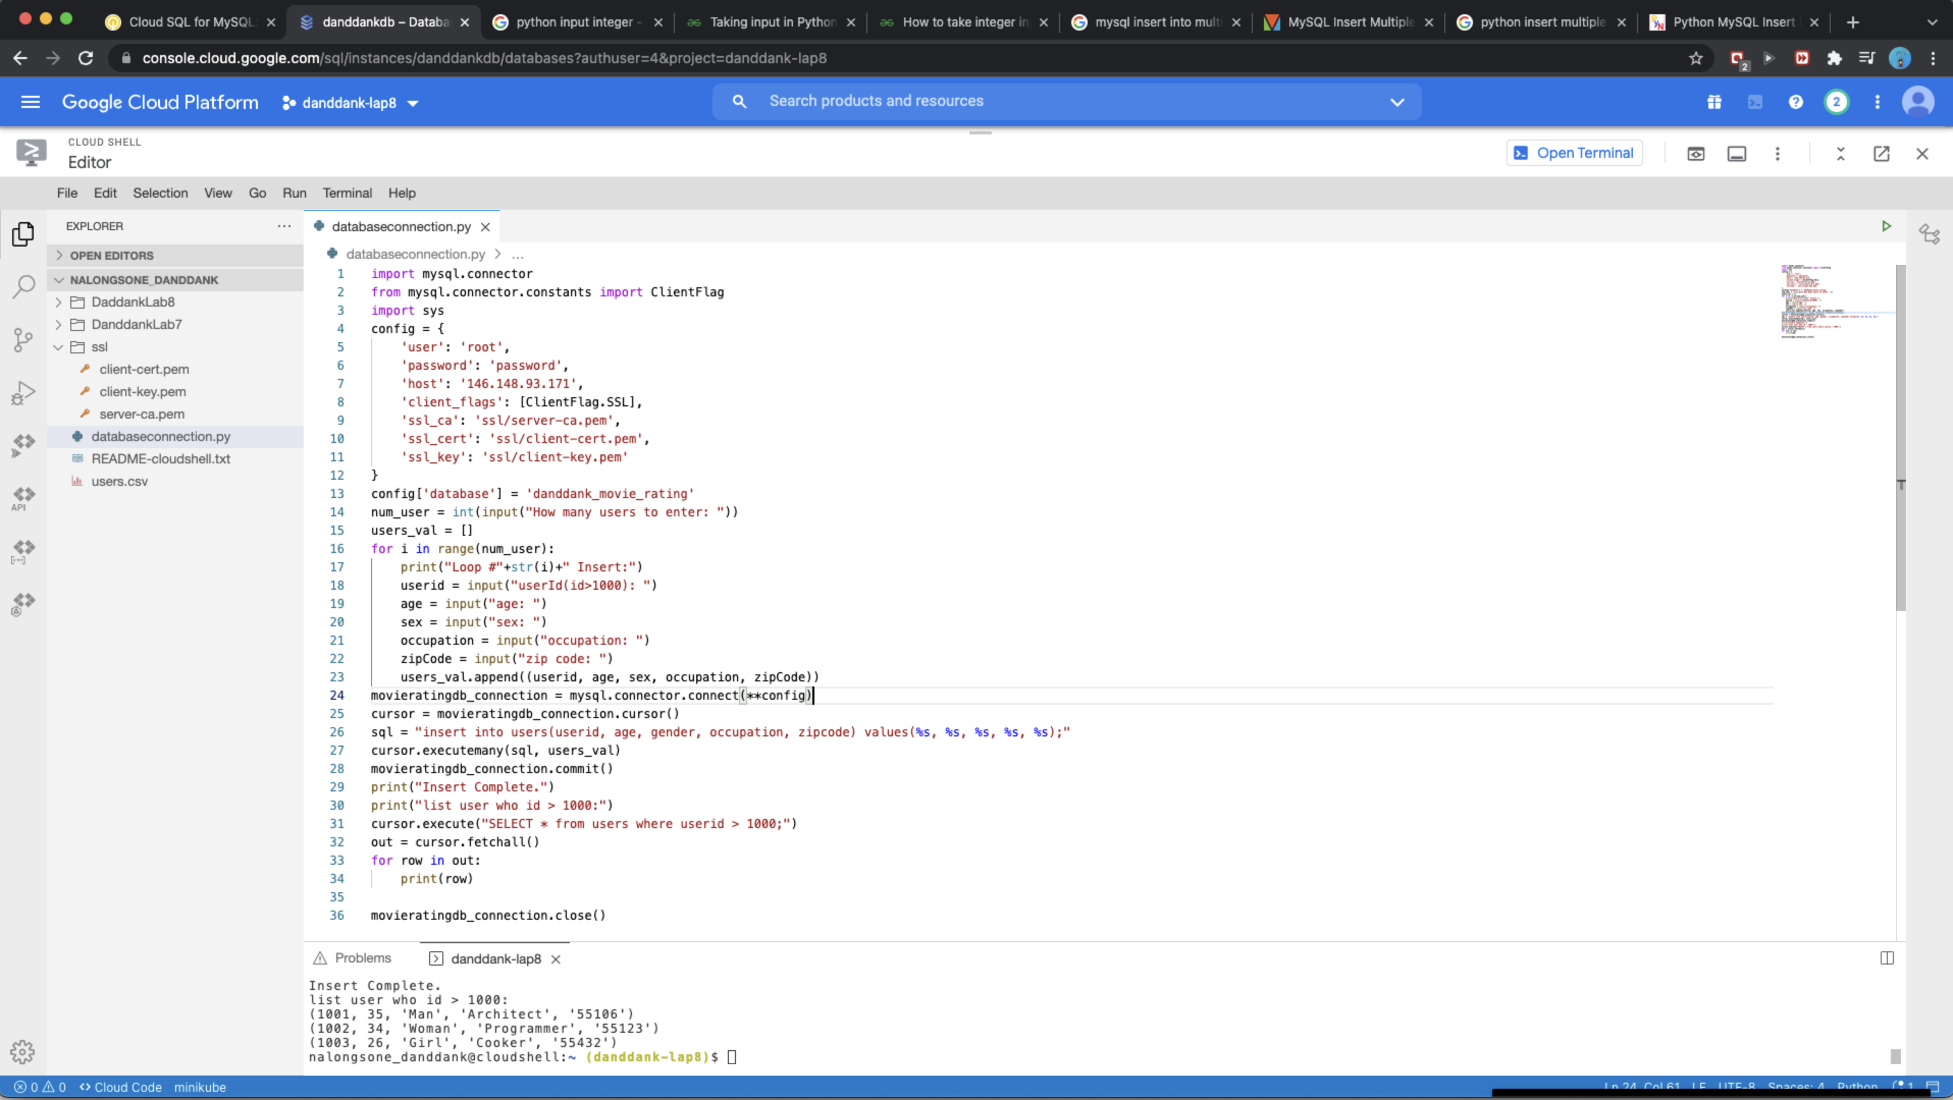

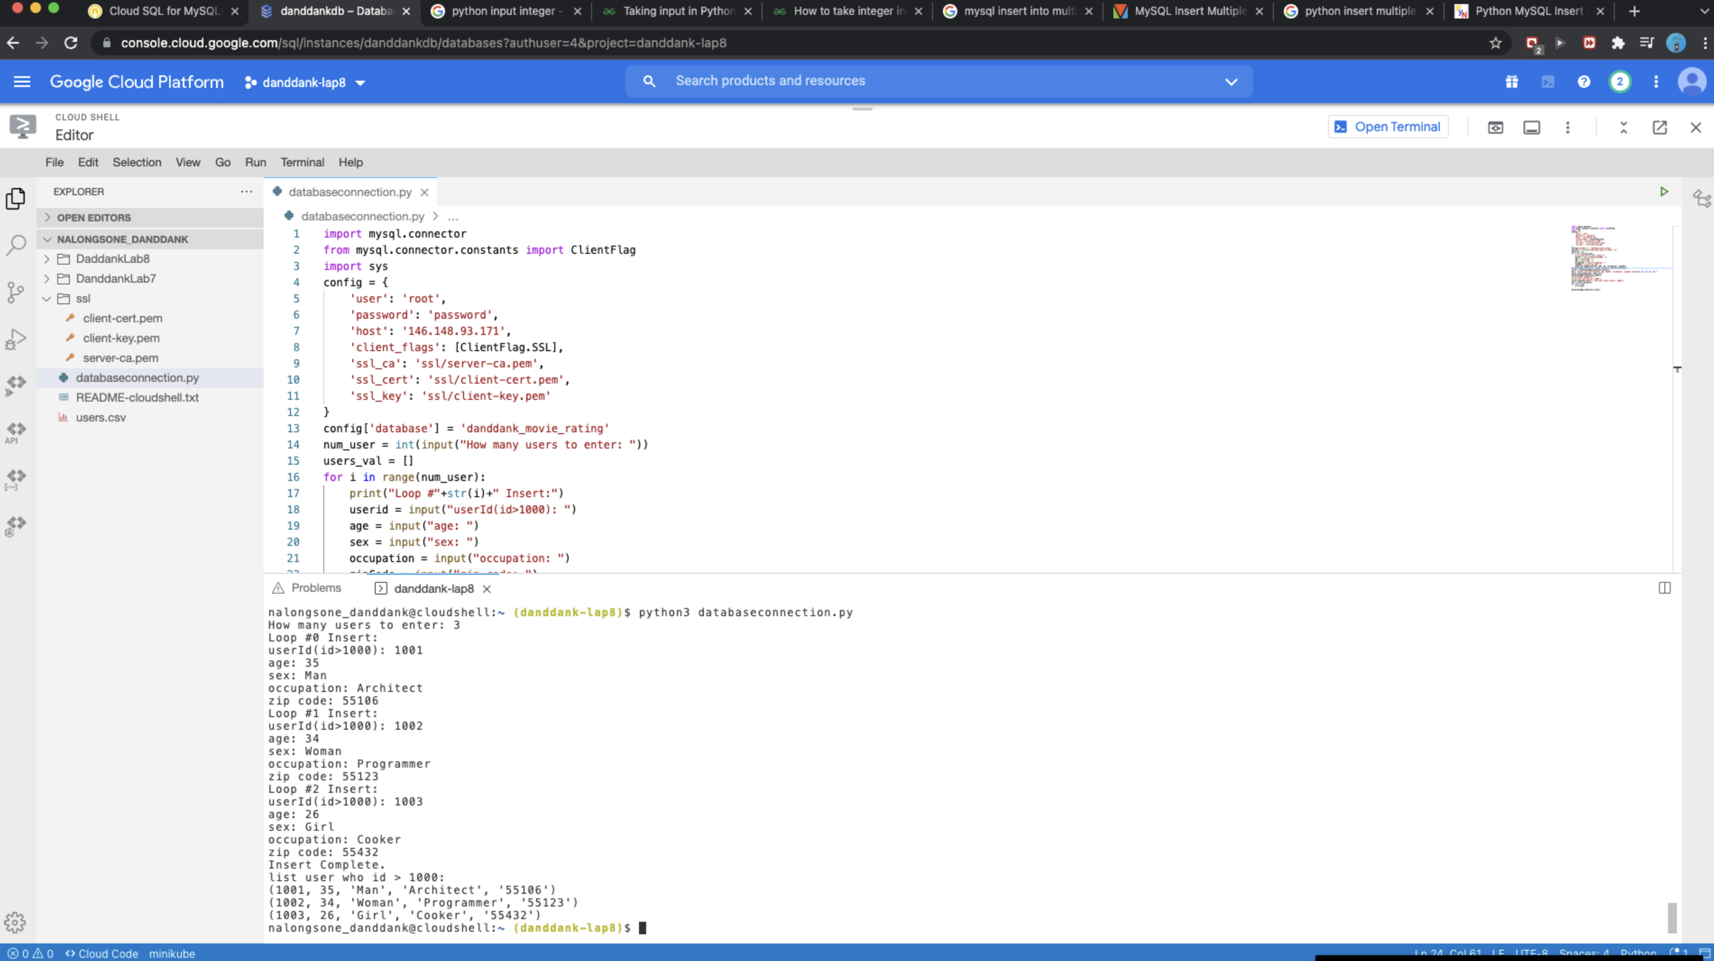

**Lab report screen-shot #20:**

